Abstract Freeform Shapes
# Source: AI Source: Provided by: [Data Path: Persons Table -> ID Column: 1, Name_En Column: Motasem Essam] -> From: [ChatGPT] on [7/25/2026]
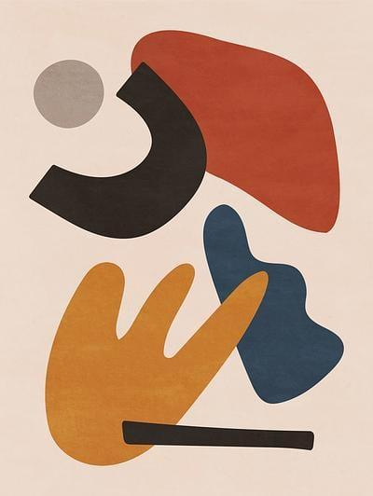
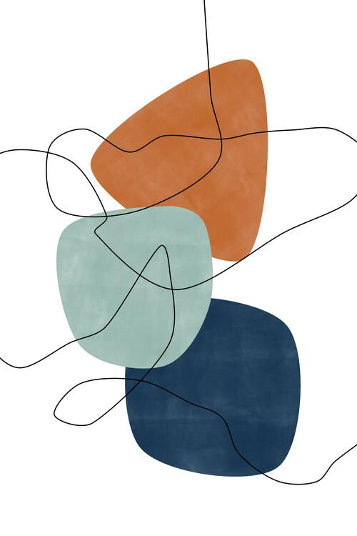
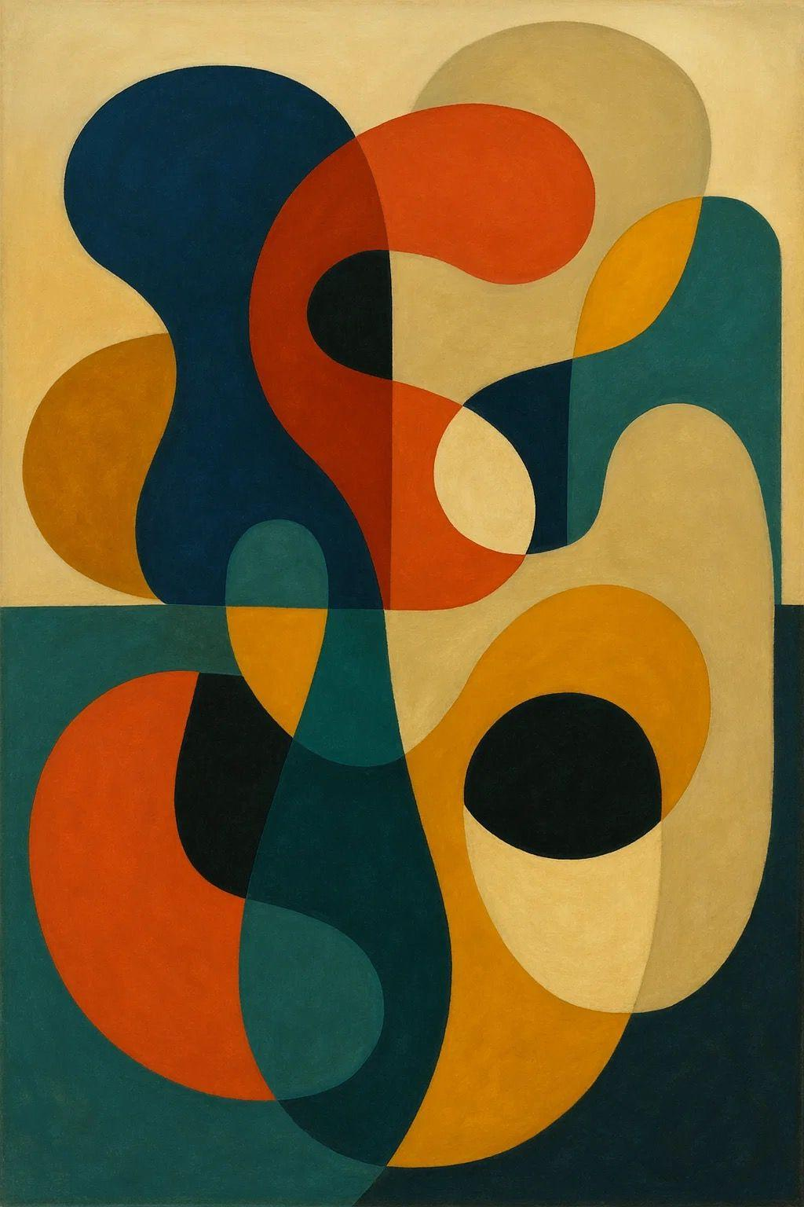
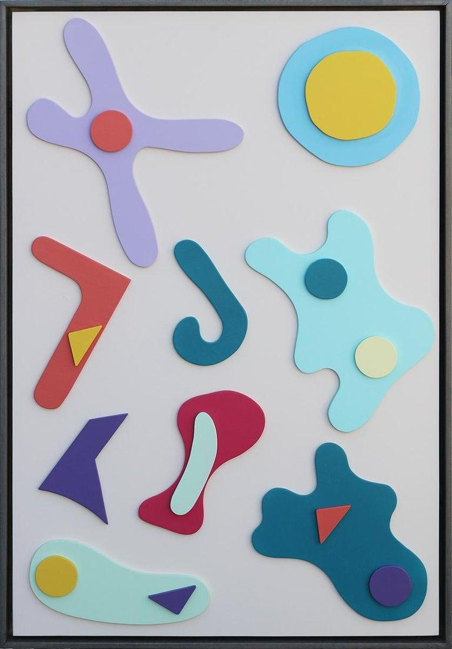
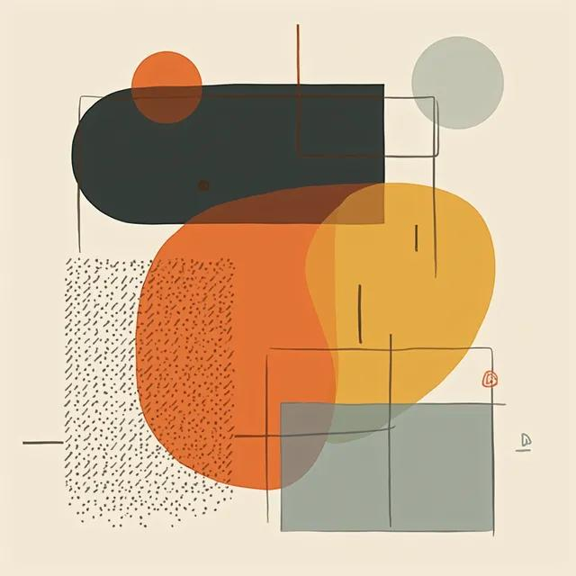
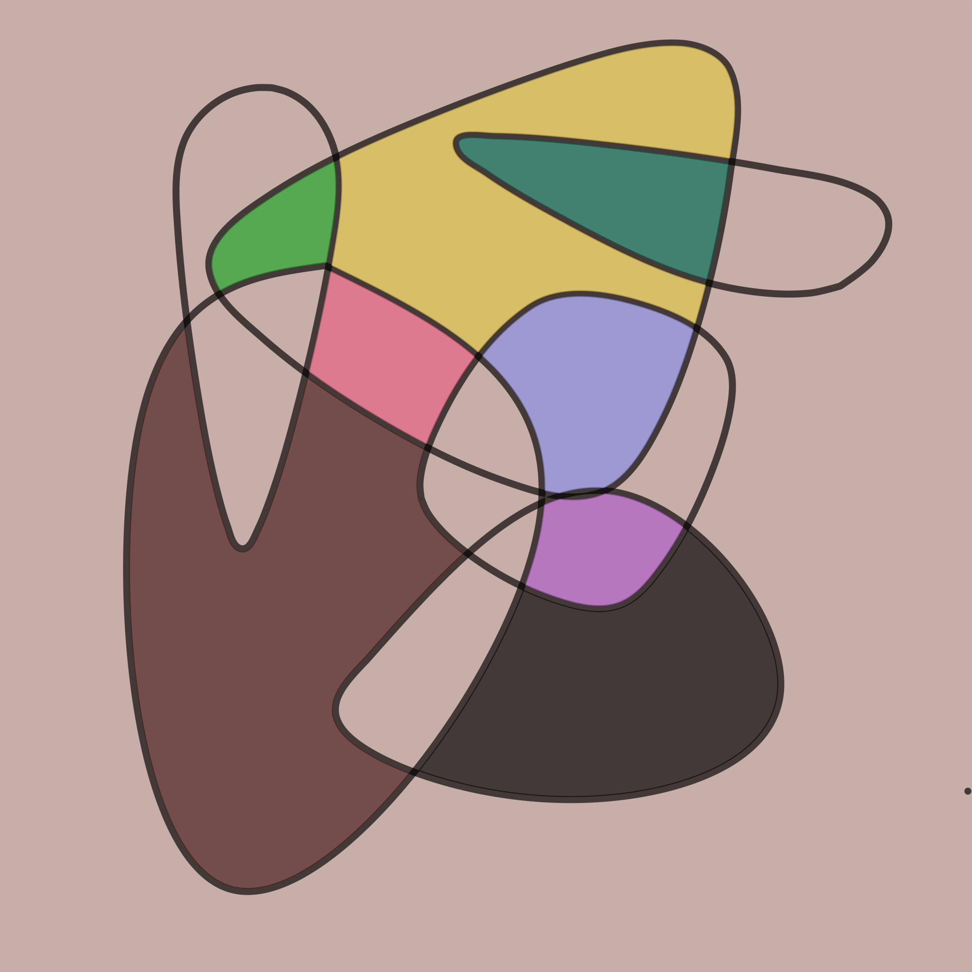
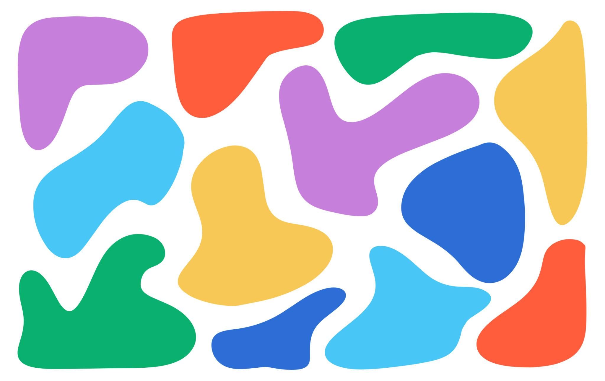

Definition
# Source: AI Source: Provided by: [Data Path: Persons Table -> ID Column: 1, Name_En Column: Motasem Essam] -> From: [ChatGPT] on [7/25/2026]
Abstract Freeform Shapes are shapes created with non-standard, flexible, and unconstrained forms that do not follow a fixed geometric structure and are not necessarily intended to represent a recognizable real-world object.
They may combine:
- Curves
- Straight-line segments
- Angles
- Irregular boundaries
- Uneven proportions
- Repeated or non-repeated elements
- Geometric and organic characteristics
The term combines two ideas:
Abstract → not necessarily representing a specific recognizable object.
Freeform → not restricted to a predetermined geometric form.

Fundamental Concept
# Source: AI Source: Provided by: [Data Path: Persons Table -> ID Column: 1, Name_En Column: Motasem Essam] -> From: [ChatGPT] on [7/25/2026]
The defining idea of an Abstract Freeform Shape is:
A shape with a deliberately non-standard form whose meaning or appearance is not determined by a conventional geometric figure or a specific real-world object.
For example, an abstract shape may consist of several curved and angular sections arranged in an unusual configuration without representing a particular object.
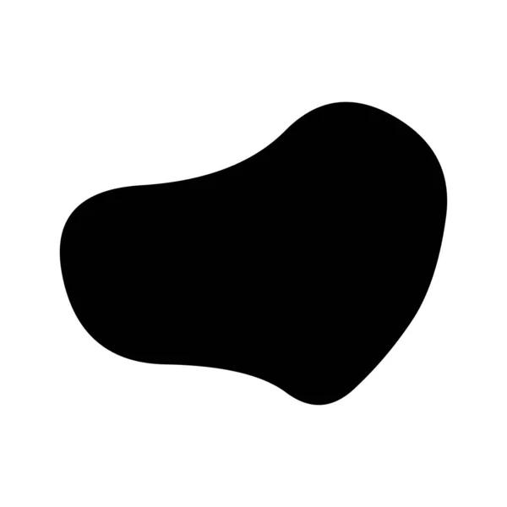
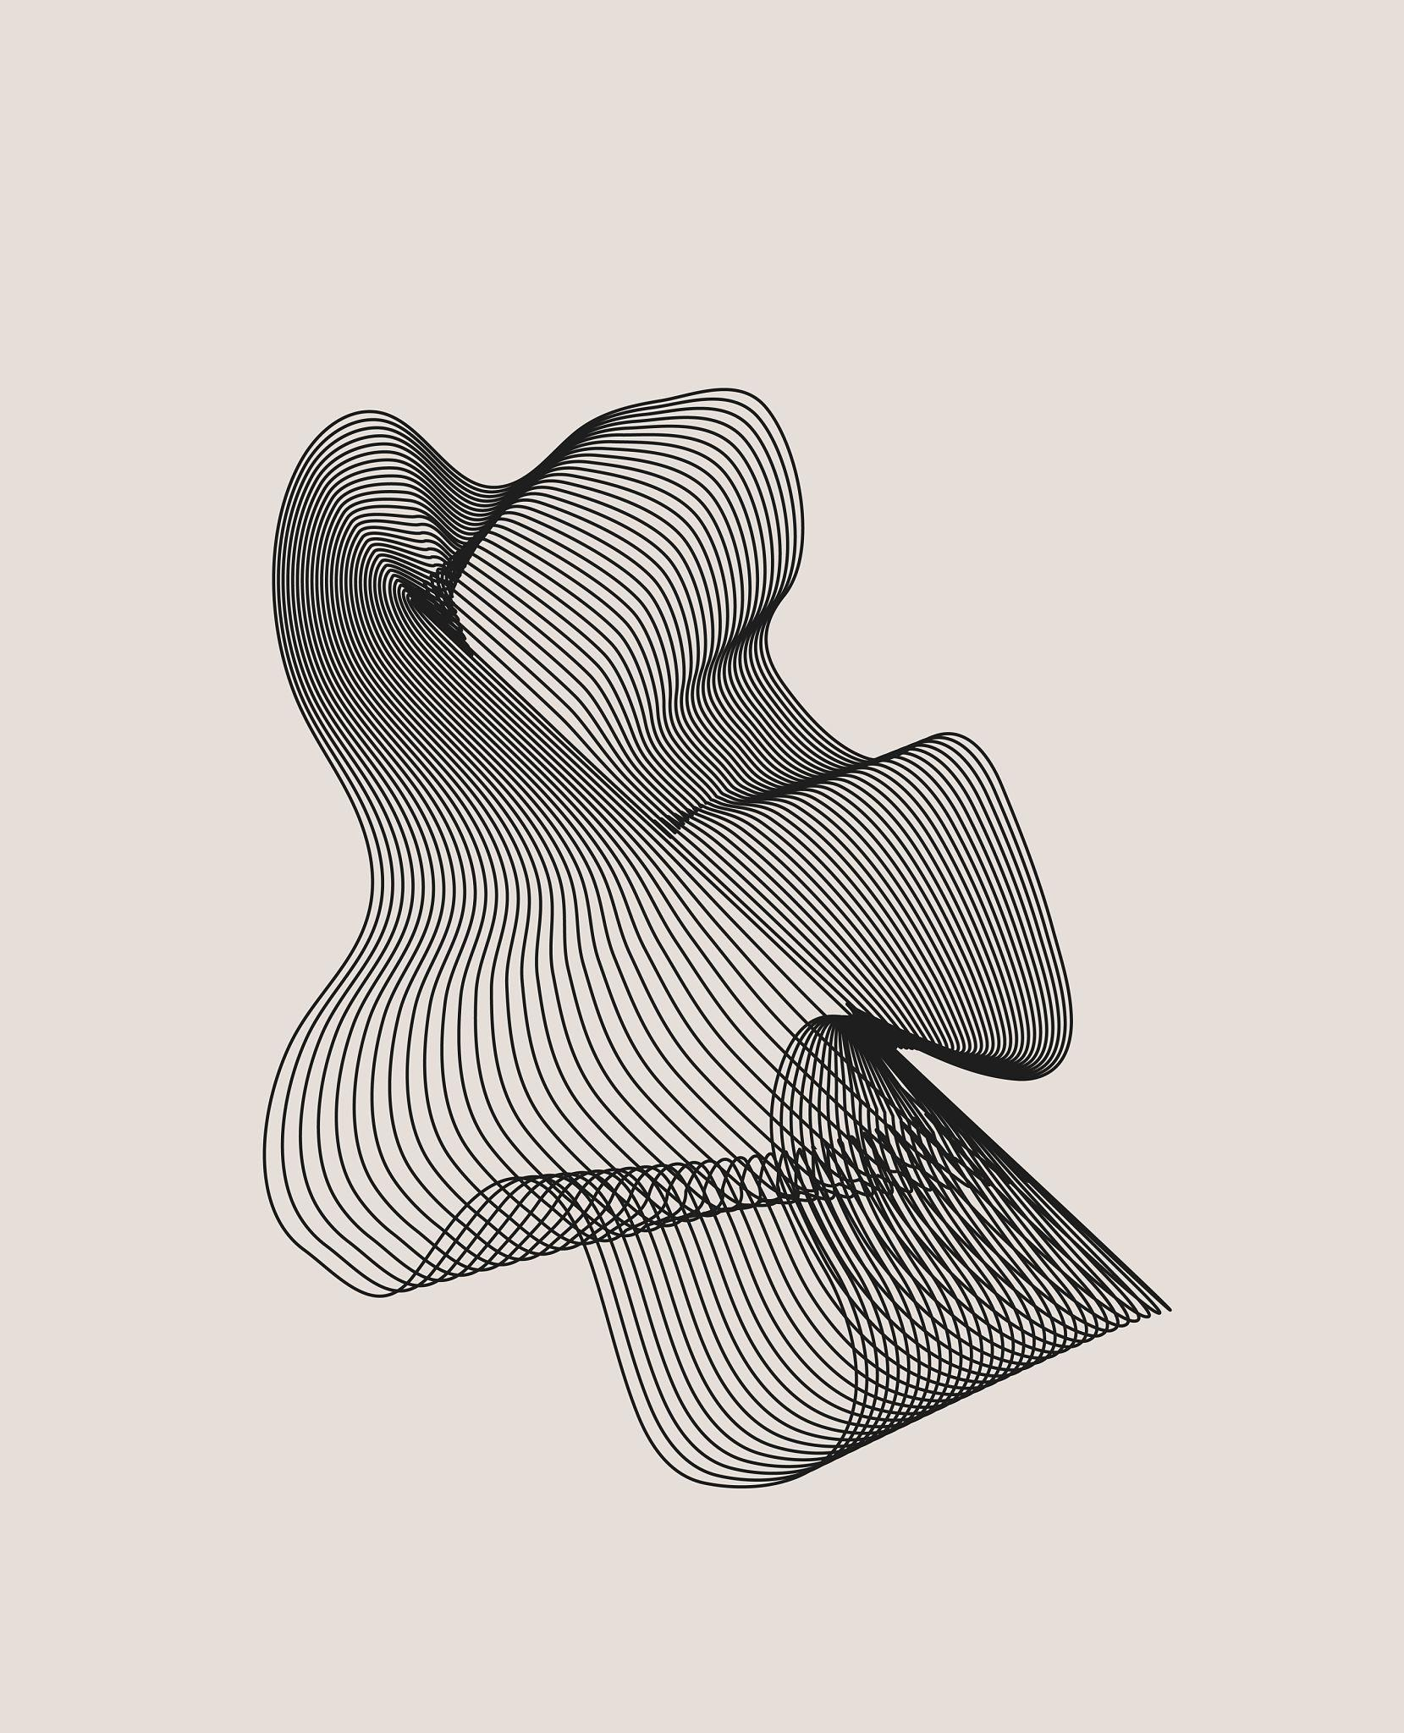
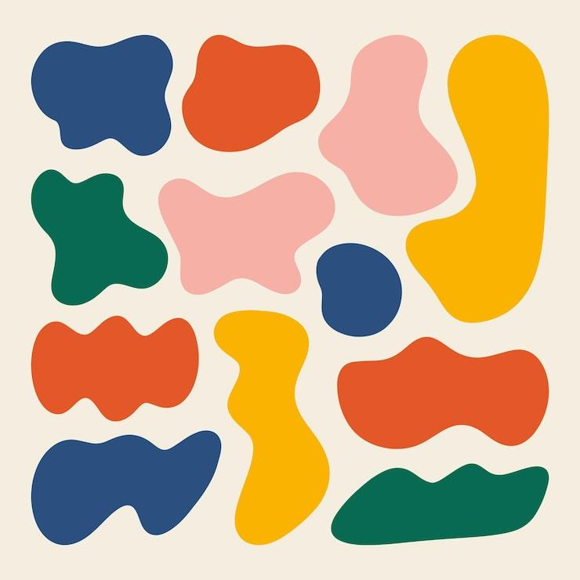
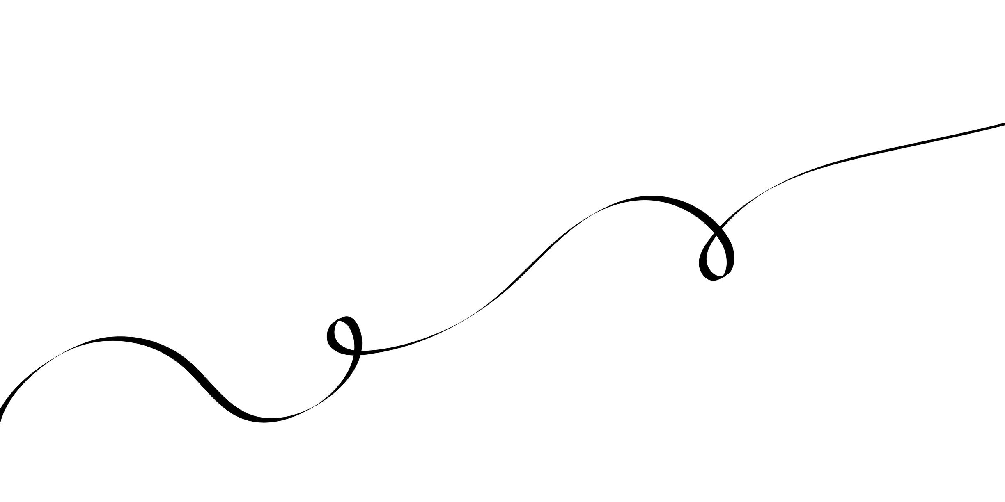
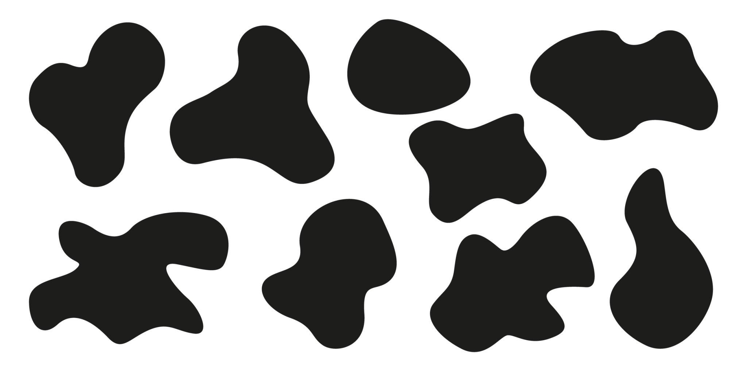
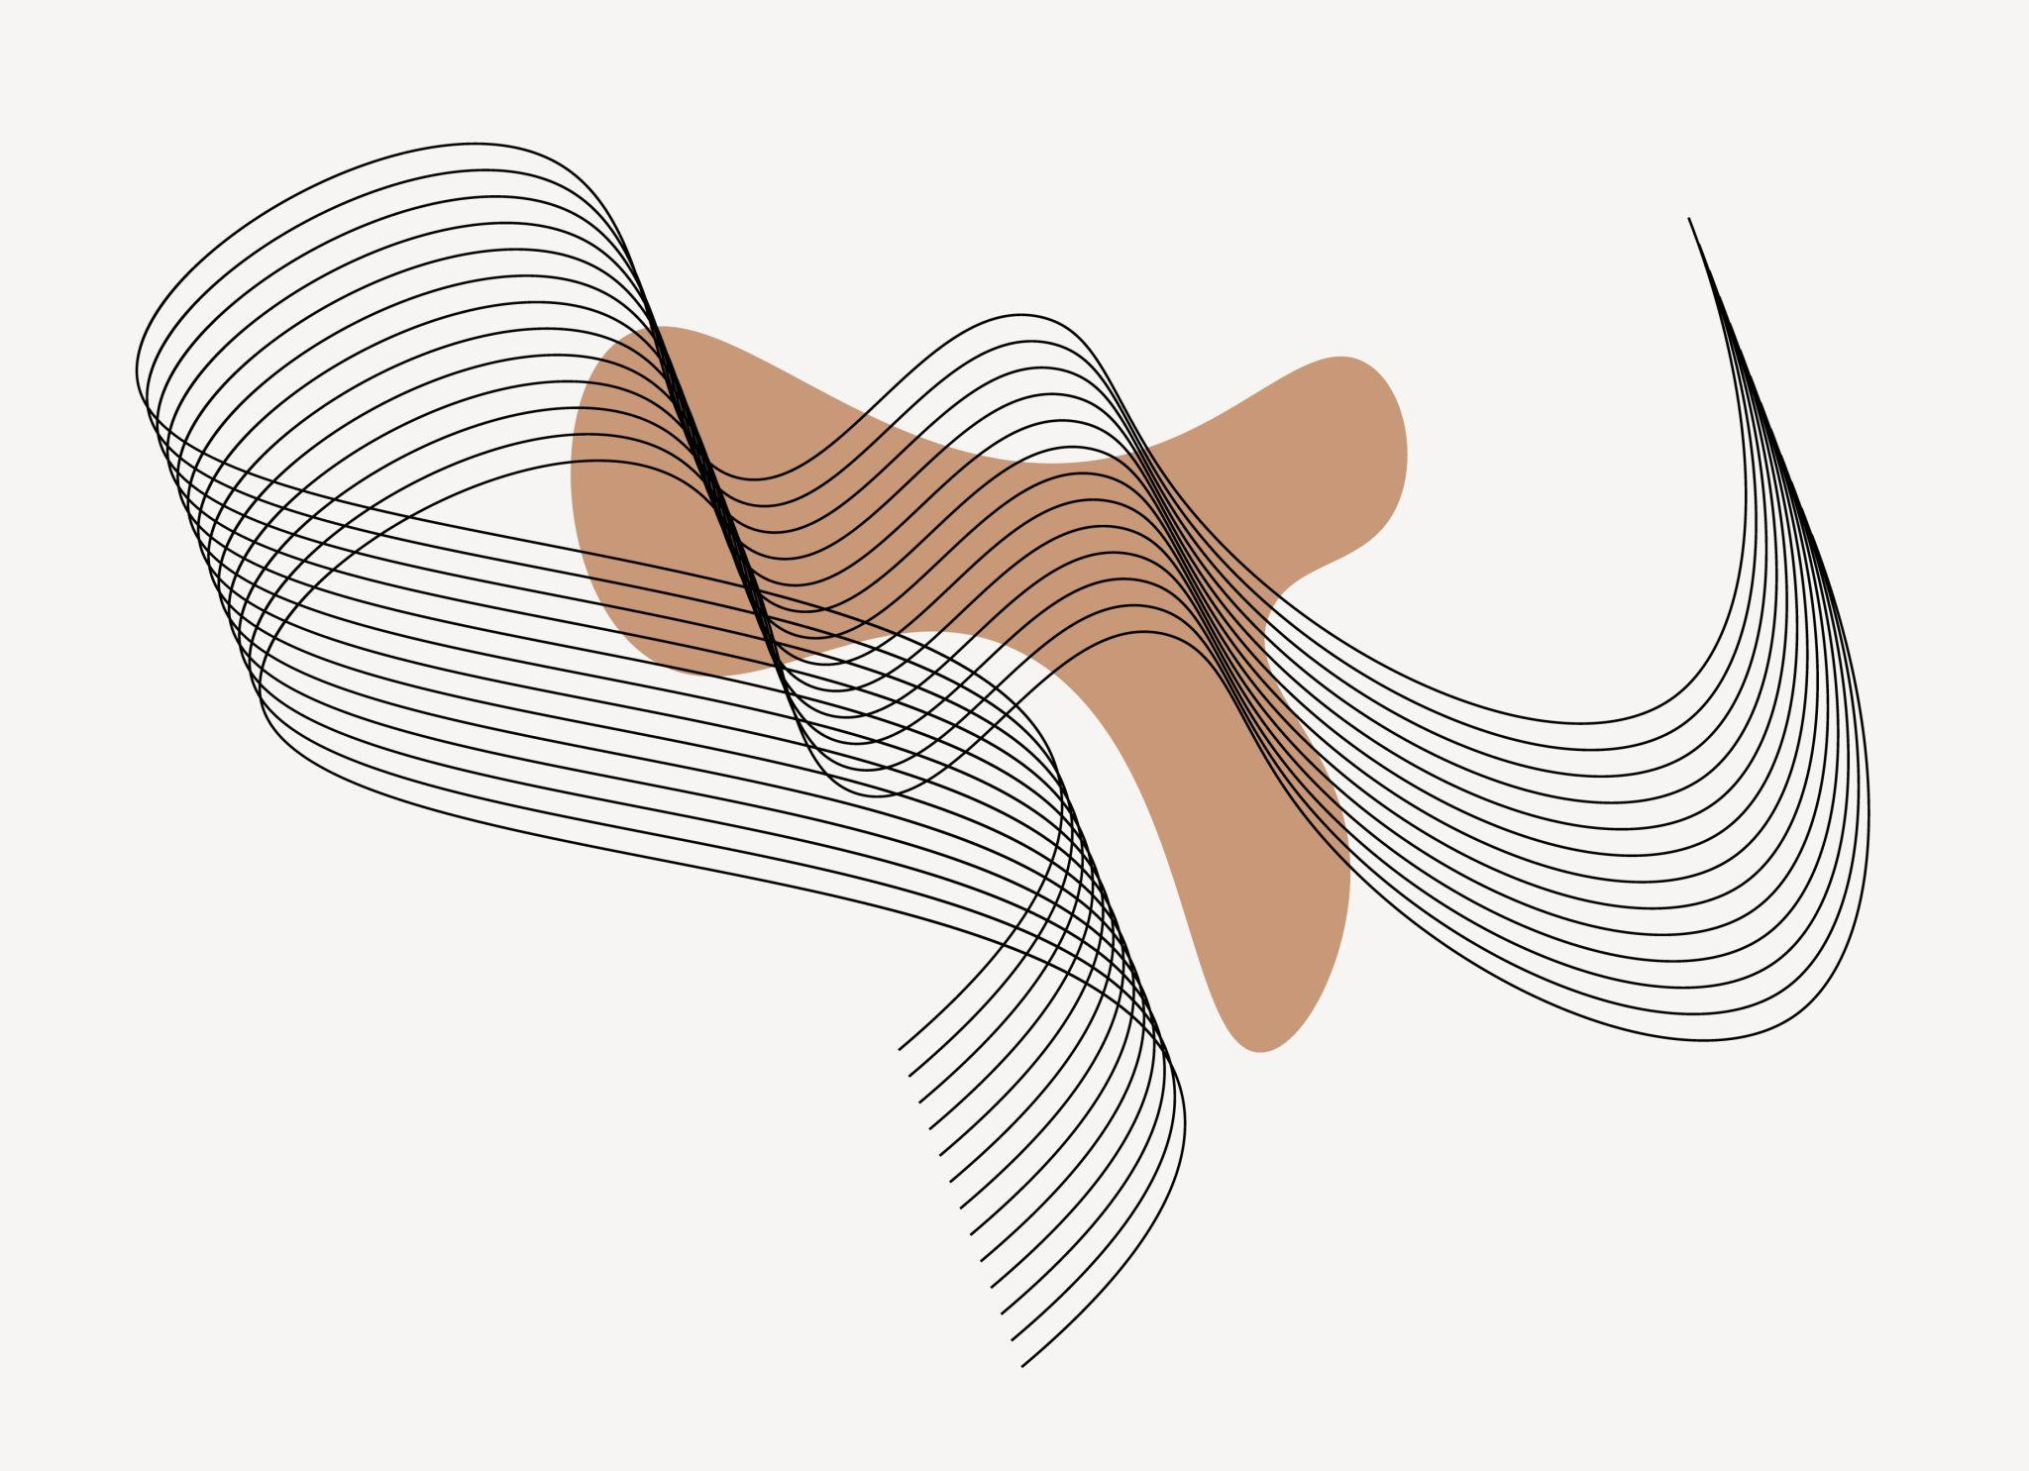

Main Characteristics
# Source: AI Source: Provided by: [Data Path: Persons Table -> ID Column: 1, Name_En Column: Motasem Essam] -> From: [ChatGPT] on [7/25/2026]
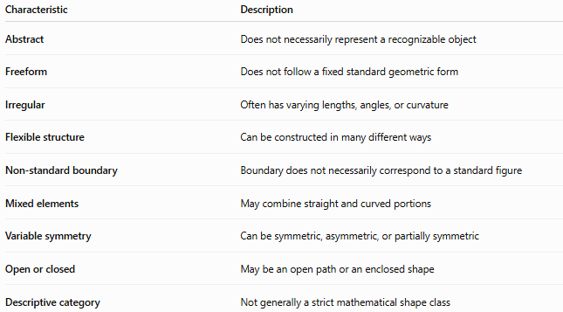
Characteristic | Description
Abstract | Does not necessarily represent a recognizable object
Freeform | Does not follow a fixed standard geometric form
Irregular | Often has varying lengths, angles, or curvature
Flexible structure | Can be constructed in many different ways
Non-standard boundary | Boundary does not necessarily correspond to a standard figure
Mixed elements | May combine straight and curved portions
Variable symmetry | Can be symmetric, asymmetric, or partially symmetric
Open or closed | May be an open path or an enclosed shape
Descriptive category | Not generally a strict mathematical shape class

Basic Structure
# Source: AI Source: Provided by: [Data Path: Persons Table -> ID Column: 1, Name_En Column: Motasem Essam] -> From: [ChatGPT] on [7/25/2026]
Abstract Freeform Shapes can contain several types of elements:
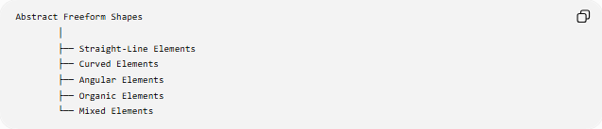
Abstract Freeform Shapes
│
├── Straight-Line Elements
├── Curved Elements
├── Angular Elements
├── Organic Elements
└── Mixed Elements
These elements can be combined without requiring the overall shape to match a standard geometric figure.

Types of Abstract Freeform Shapes
# Source: AI Source: Provided by: [Data Path: Persons Table -> ID Column: 1, Name_En Column: Motasem Essam] -> From: [ChatGPT] on [7/25/2026]
A useful descriptive classification is:
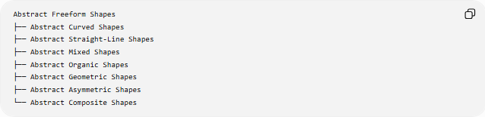
Abstract Freeform Shapes
├── Abstract Curved Shapes
├── Abstract Straight-Line Shapes
├── Abstract Mixed Shapes
├── Abstract Organic Shapes
├── Abstract Geometric Shapes
├── Abstract Asymmetric Shapes
└── Abstract Composite Shapes
These categories can overlap.
For example, a shape can simultaneously be:
Abstract + Freeform + Curved + Asymmetric

1-Abstract Curved Shapes
# Source: AI Source: Provided by: [Data Path: Persons Table -> ID Column: 1, Name_En Column: Motasem Essam] -> From: [ChatGPT] on [7/25/2026]
Shapes primarily formed from irregular curves.
They may contain:
- Smooth curves
- Wavy boundaries
- Loops
- Bulges
- Indentations
- Changing curvature
They do not need to represent a recognizable object.

2-Abstract Straight-Line Shapes
# Source: AI Source: Provided by: [Data Path: Persons Table -> ID Column: 1, Name_En Column: Motasem Essam] -> From: [ChatGPT] on [7/25/2026]
Shapes primarily composed of straight-line segments but arranged without a fixed standard form.
They may contain:
- Unequal segment lengths
- Different directions
- Irregular angles
- Unusual proportions
A closed example is technically a polygon if its boundary is composed entirely of straight segments.

3-Abstract Mixed Shapes
# Source: AI Source: Provided by: [Data Path: Persons Table -> ID Column: 1, Name_En Column: Motasem Essam] -> From: [ChatGPT] on [7/25/2026]
Shapes combining different types of elements.
For example:
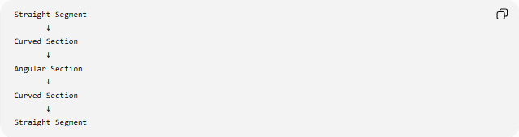
Straight Segment
↓
Curved Section
↓
Angular Section
↓
Curved Section
↓
Straight Segment
These are especially useful when the designer does not want the shape to belong to a single standard geometric category.

4-Abstract Organic Shapes
# Source: AI Source: Provided by: [Data Path: Persons Table -> ID Column: 1, Name_En Column: Motasem Essam] -> From: [ChatGPT] on [7/25/2026]
Shapes that combine abstract design with organic characteristics.
They may have:
- Flowing curves
- Irregular bulges
- Uneven indentations
- Natural-looking contours
Unlike a nature-inspired organic shape, an abstract organic shape does not necessarily represent a particular natural object.

5-Abstract Geometric Shapes
# Source: AI Source: Provided by: [Data Path: Persons Table -> ID Column: 1, Name_En Column: Motasem Essam] -> From: [ChatGPT] on [7/25/2026]
These are abstract arrangements that use recognizable geometric elements but combine them in a non-standard way.
For example, an abstract shape may combine:
- Triangular sections
- Circular arcs
- Rectangular portions
- Angled segments
The individual components may be geometric, while the overall composition is abstract and freeform.

6-Abstract Asymmetric Shapes
# Source: AI Source: Provided by: [Data Path: Persons Table -> ID Column: 1, Name_En Column: Motasem Essam] -> From: [ChatGPT] on [7/25/2026]
Shapes that do not have the specified symmetry being considered.
For example, if reflection across a particular axis does not leave the shape unchanged:
$$R\left(S\right)≠S$$
then the shape lacks that reflection symmetry.
Asymmetry is not required for abstraction, but many abstract freeform shapes are asymmetric.

7-Abstract Composite Shapes
# Source: AI Source: Provided by: [Data Path: Persons Table -> ID Column: 1, Name_En Column: Motasem Essam] -> From: [ChatGPT] on [7/25/2026]
Shapes constructed from multiple distinct components.
The components may be:
- Connected
- Overlapping
- Nested
- Separated
For example:
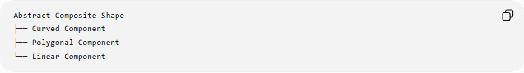
Abstract Composite Shape
├── Curved Component
├── Polygonal Component
└── Linear Component
The complete composition can therefore be abstract even when individual components have recognizable geometric forms.

Open and Closed Abstract Freeform Shapes

Open Abstract Freeform Shapes
# Source: AI Source: Provided by: [Data Path: Persons Table -> ID Column: 1, Name_En Column: Motasem Essam] -> From: [ChatGPT] on [7/25/2026]
An open shape has two endpoints and does not completely enclose a region.
It can be represented by a parametric curve:
$$r\left(t\right)=\left(x , \left(t\right)y\left(t\right)\right)$$
with:
$$r\left(a\right)≠r\left(b\right)$$
Examples include abstract freeform lines, paths, and strokes.

Closed Abstract Freeform Shapes
# Source: AI Source: Provided by: [Data Path: Persons Table -> ID Column: 1, Name_En Column: Motasem Essam] -> From: [ChatGPT] on [7/25/2026]
A closed shape returns to its starting point:
$$r\left(a\right)=r\left(b\right)$$
and can enclose a region.
Its boundary may contain both straight and curved sections.
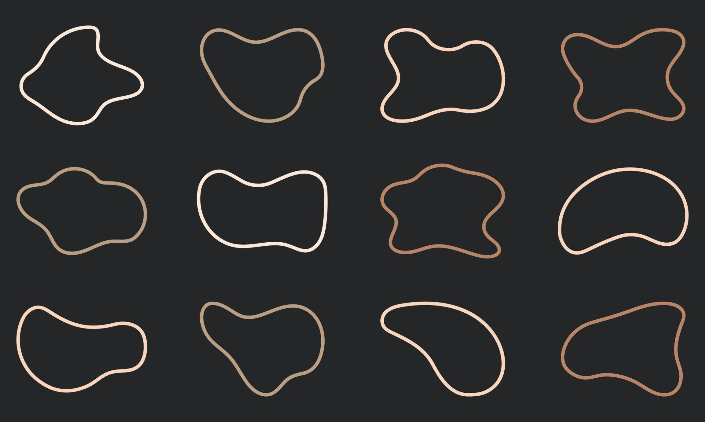
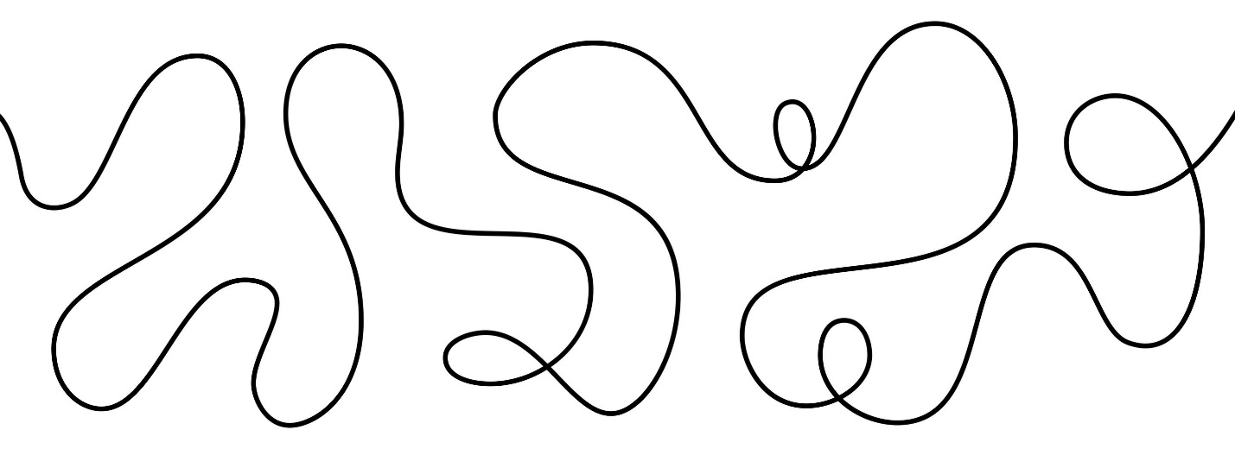
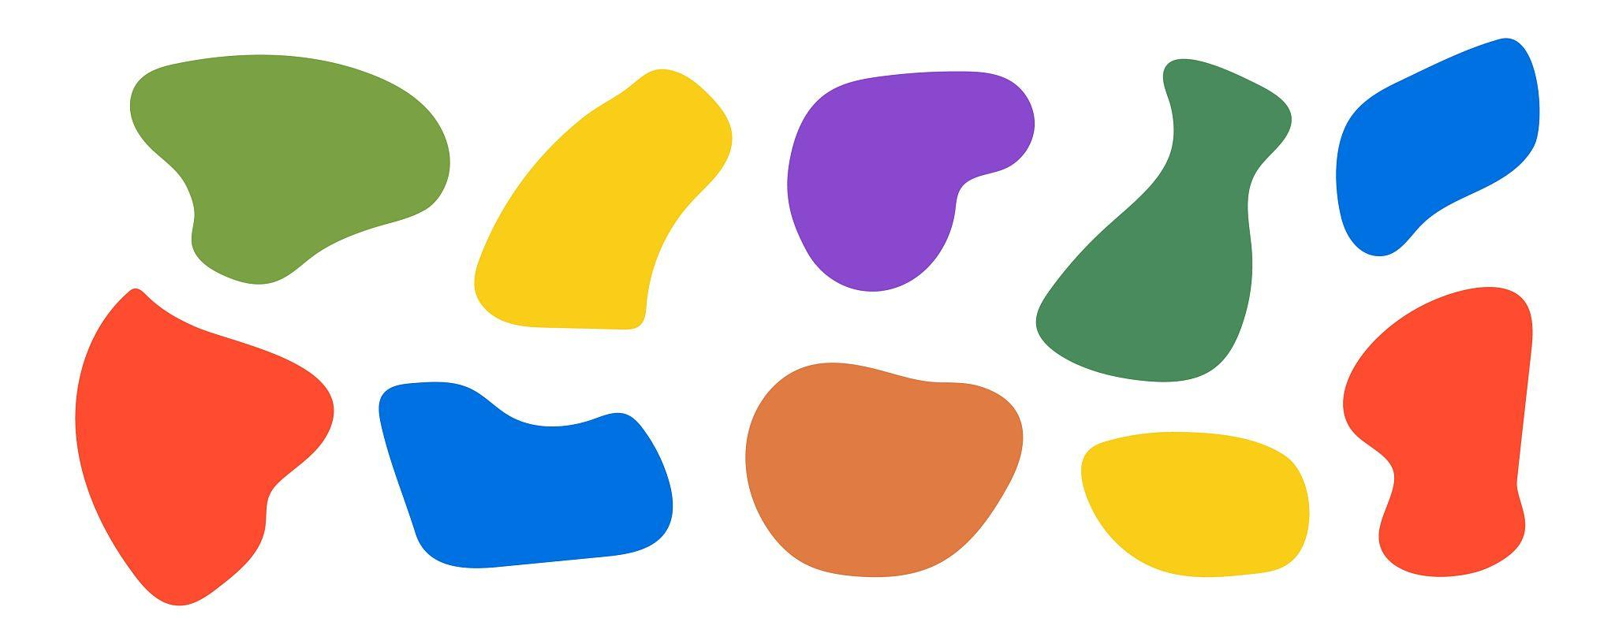
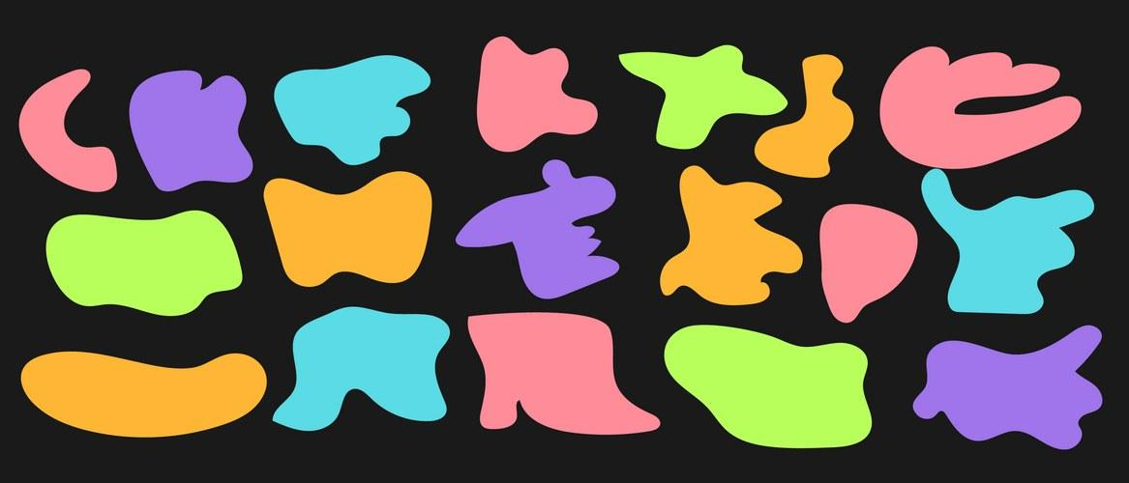
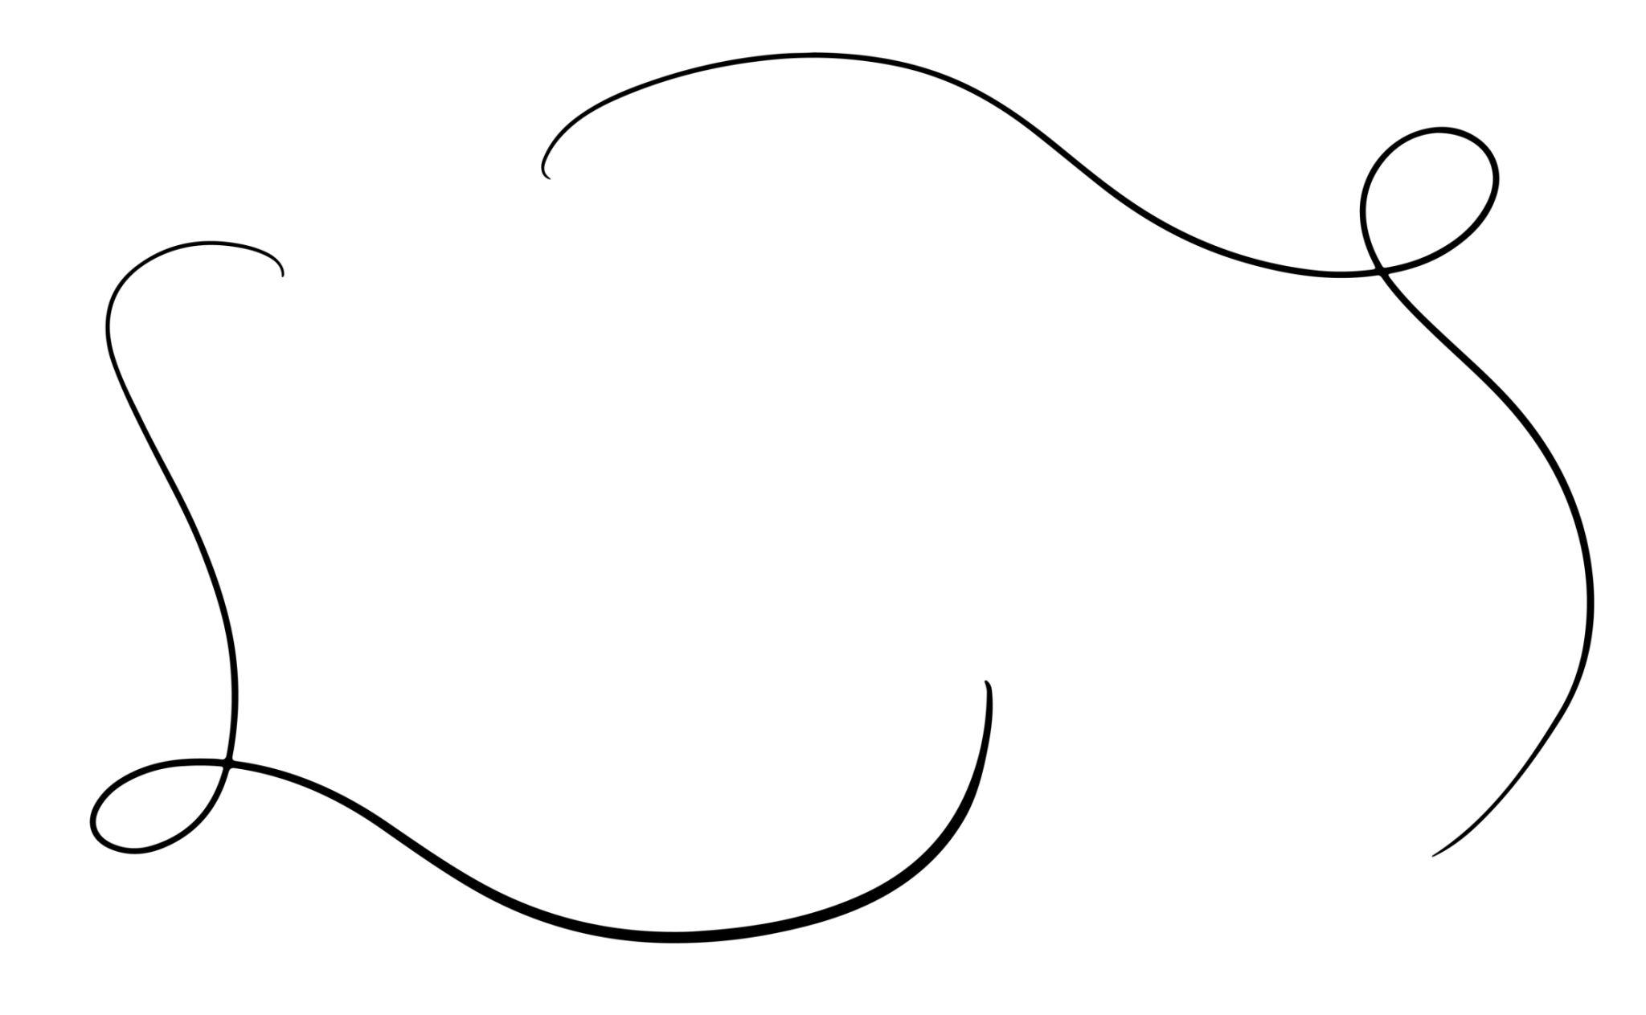
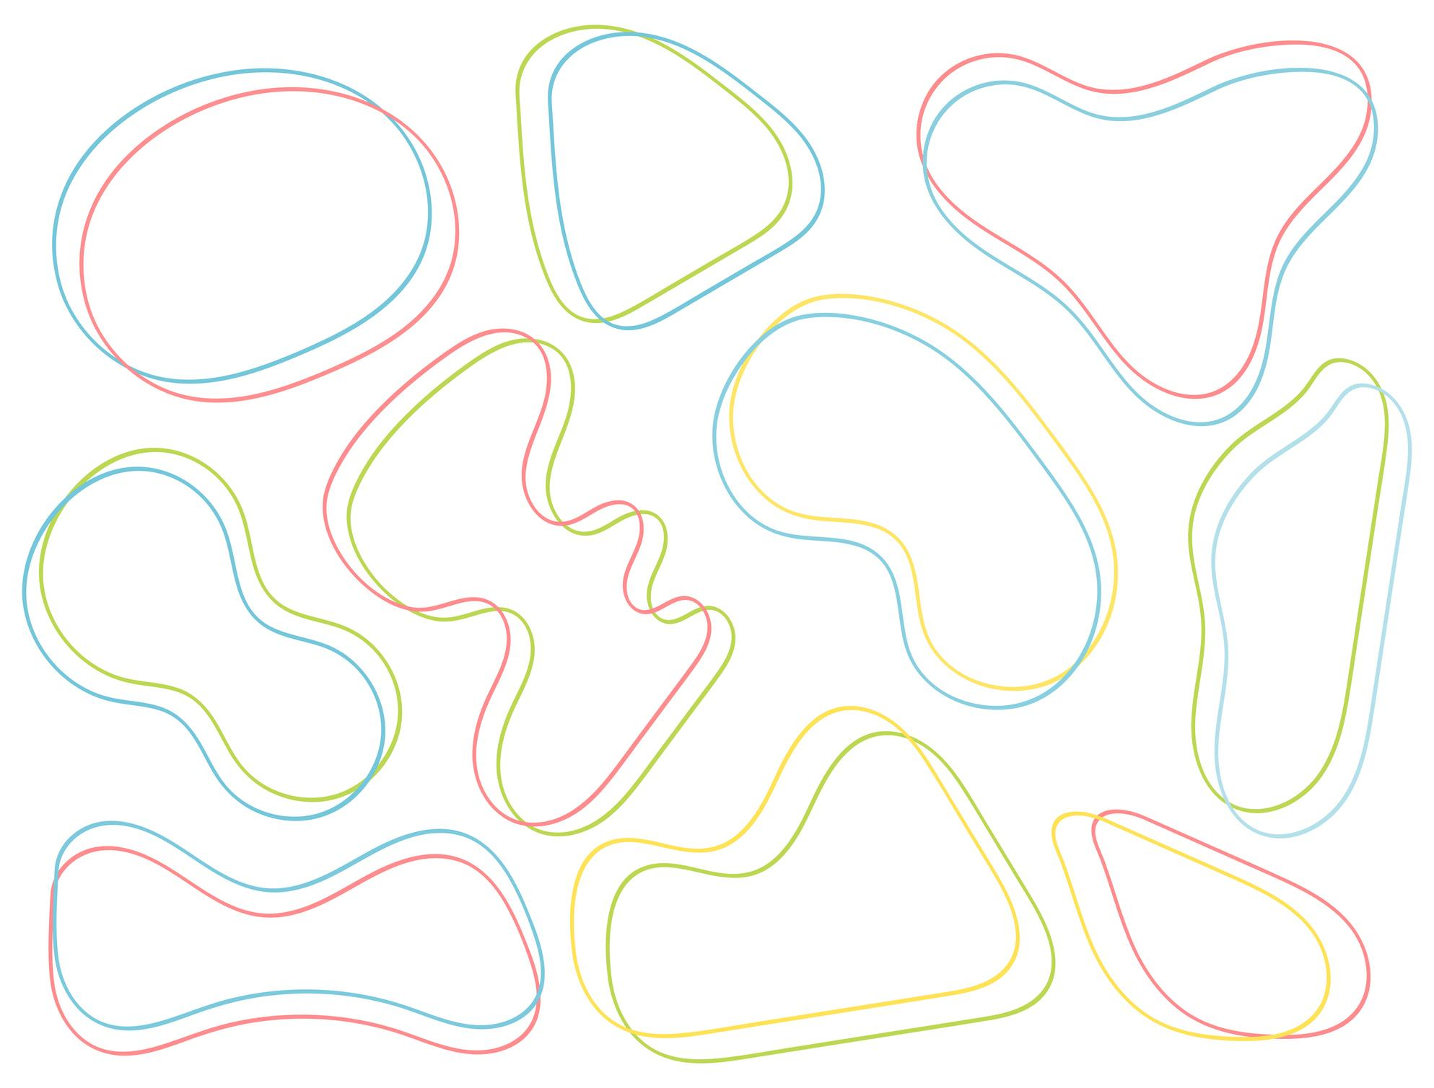

Mathematical Representation
# Source: AI Source: Provided by: [Data Path: Persons Table -> ID Column: 1, Name_En Column: Motasem Essam] -> From: [ChatGPT] on [7/25/2026]
Although the term Abstract Freeform Shape is primarily descriptive, the shape can still be represented mathematically.
Parametric representation
$$r\left(t\right)=\left(x , \left(t\right)y\left(t\right)\right)$$
where the functions determine the position of points along the boundary.
Piecewise representation
A mixed abstract shape can be represented by:
$$r\left(t\right)=\left\{\begin{matrix}r_{1}\left(t\right), & a≤t<c \\ r_{2}\left(t\right), & c≤t<d \\ r_{3}\left(t\right), & d≤t≤e\end{matrix}\right.$$
Different portions may represent different geometric elements.
For example:
- $r_{1}\left(t\right)$→ line segment
- $r_{2}\left(t\right)$→ curved section
- $r_{3}\left(t\right)$→ another curve or line

Boundary and Curvature
# Source: AI Source: Provided by: [Data Path: Persons Table -> ID Column: 1, Name_En Column: Motasem Essam] -> From: [ChatGPT] on [7/25/2026]
For a smooth boundary represented by:
$$y=f\left(x\right)$$
its curvature is:
$$κ=\frac{∣f^{''}\left(x\right)∣}{{\left(1+{\left[f^{'}\left(x\right)\right]}^{2}\right)}^{3/2}}$$
In an abstract freeform shape, the curvature can vary substantially from one section to another.
Some sections may have:
- Low curvature
- High curvature
- Nearly straight portions
- Rapidly changing curvature
This variation contributes to the freeform character.

Area and Perimeter
# Source: AI Source: Provided by: [Data Path: Persons Table -> ID Column: 1, Name_En Column: Motasem Essam] -> From: [ChatGPT] on [7/25/2026]
For a closed abstract freeform shape, the boundary length can be represented by:
$$L=\int_{a}^{b}{\sqrt{{\left(\frac{dx}{dt}\right)}^{2}+{\left(\frac{dy}{dt}\right)}^{2}}} dt$$
For a closed smooth boundary, the enclosed area can be calculated using:
$$A=\frac{1}{2}\oint{(}\left.x dy-y dx\right)$$
For a boundary containing both straight and curved portions:
$$P=\sum{L_{\text{straight}}}+\sum{L_{\text{curved}}}$$

Symmetry
# Source: AI Source: Provided by: [Data Path: Persons Table -> ID Column: 1, Name_En Column: Motasem Essam] -> From: [ChatGPT] on [7/25/2026]
Abstract Freeform Shapes may be:
- Symmetric
- Asymmetric
- Partially symmetric
Possible symmetry types include:
- Reflection symmetry
- Rotational symmetry
- Point symmetry
For a transformation $T$, symmetry can be expressed as:
$$T\left(S\right)=S$$
The abstract nature of a shape does not prevent it from having mathematical symmetry.

Abstract Freeform Shapes vs Other Freeform Shapes
# Source: AI Source: Provided by: [Data Path: Persons Table -> ID Column: 1, Name_En Column: Motasem Essam] -> From: [ChatGPT] on [7/25/2026]
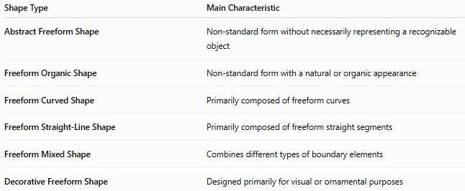
Shape Type | Main Characteristic
Abstract Freeform Shape | Non-standard form without necessarily representing a recognizable object
Freeform Organic Shape | Non-standard form with a natural or organic appearance
Freeform Curved Shape | Primarily composed of freeform curves
Freeform Straight-Line Shape | Primarily composed of freeform straight segments
Freeform Mixed Shape | Combines different types of boundary elements
Decorative Freeform Shape | Designed primarily for visual or ornamental purposes
Important distinction
Abstract describes the relationship between the shape and recognizable representation.
Freeform describes the absence of a fixed geometric structure.
Therefore, the two terms describe different properties.

Abstract vs Organic
# Source: AI Source: Provided by: [Data Path: Persons Table -> ID Column: 1, Name_En Column: Motasem Essam] -> From: [ChatGPT] on [7/25/2026]
These terms should not be treated as synonyms.
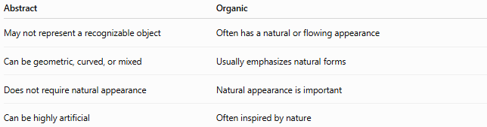
Abstract | Organic
May not represent a recognizable object | Often has a natural or flowing appearance
Can be geometric, curved, or mixed | Usually emphasizes natural forms
Does not require natural appearance | Natural appearance is important
Can be highly artificial | Often inspired by nature
A shape can therefore be:
Abstract + Organic + Freeform
but an abstract freeform shape does not have to be organic.

Abstract vs Irregular
# Source: AI Source: Provided by: [Data Path: Persons Table -> ID Column: 1, Name_En Column: Motasem Essam] -> From: [ChatGPT] on [7/25/2026]
Irregular means that a shape does not satisfy the regularity conditions of its relevant geometric class.
Abstract means that the shape is not necessarily intended to represent a recognizable object or standard geometric form.
Therefore:
$$\text{Abstract}≠\text{Irregular}$$
An irregular pentagon can still be a precisely defined geometric shape, while an abstract freeform shape may not correspond to a standard polygon or other conventional geometric class.

Examples

Example 1 — Abstract Curved Form
# Source: AI Source: Provided by: [Data Path: Persons Table -> ID Column: 1, Name_En Column: Motasem Essam] -> From: [ChatGPT] on [7/25/2026]
An irregular collection of smooth curves forming an unusual closed boundary can be an Abstract Freeform Shape.

Example 2 — Abstract Angular Form
# Source: AI Source: Provided by: [Data Path: Persons Table -> ID Column: 1, Name_En Column: Motasem Essam] -> From: [ChatGPT] on [7/25/2026]
A collection of unequal straight segments and unusual angles can form an abstract freeform polygonal shape.

Example 3 — Abstract Mixed Form
# Source: AI Source: Provided by: [Data Path: Persons Table -> ID Column: 1, Name_En Column: Motasem Essam] -> From: [ChatGPT] on [7/25/2026]
A shape combining:
- Straight edges
- Circular arcs
- Freeform curves
can be classified as an Abstract Freeform Shape.

Example 4 — Abstract Composite Form
# Source: AI Source: Provided by: [Data Path: Persons Table -> ID Column: 1, Name_En Column: Motasem Essam] -> From: [ChatGPT] on [7/25/2026]
Several geometric and organic components can be combined into one composition without representing a particular object.

Classification Summary
# Source: AI Source: Provided by: [Data Path: Persons Table -> ID Column: 1, Name_En Column: Motasem Essam] -> From: [ChatGPT] on [7/25/2026]
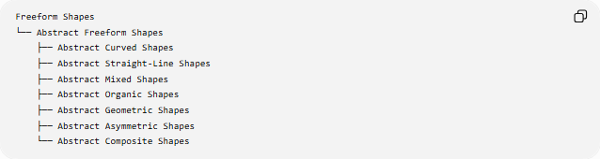
Freeform Shapes
└── Abstract Freeform Shapes
├── Abstract Curved Shapes
├── Abstract Straight-Line Shapes
├── Abstract Mixed Shapes
├── Abstract Organic Shapes
├── Abstract Geometric Shapes
├── Abstract Asymmetric Shapes
└── Abstract Composite Shapes
A structural classification can also be expressed as:
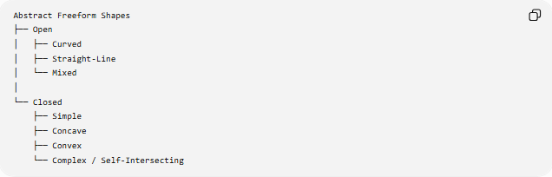
Abstract Freeform Shapes
├── Open
│ ├── Curved
│ ├── Straight-Line
│ └── Mixed
│
└── Closed
├── Simple
├── Concave
├── Convex
└── Complex / Self-Intersecting
These classifications describe different properties, so they can overlap.
For example:
Closed + Abstract + Freeform + Mixed + Asymmetric
is a valid combination.

Key Points
# Source: AI Source: Provided by: [Data Path: Persons Table -> ID Column: 1, Name_En Column: Motasem Essam] -> From: [ChatGPT] on [7/25/2026]
- Abstract Freeform Shapes have non-standard, flexible forms.
- They do not necessarily represent a recognizable real-world object.
- They do not follow a fixed standard geometric structure.
- They may contain straight lines, curves, angles, or combinations of these.
- They can be open or closed.
- They can be symmetric, asymmetric, or partially symmetric.
- A closed all-straight abstract freeform boundary is technically a polygon, even if its overall design is abstract.
- Abstract and freeform describe different properties.
- Abstract does not mean mathematically undefined.
- A freeform abstract shape can still have measurable length, perimeter, area, curvature, and coordinates.
- The category is primarily descriptive, rather than a strict universal mathematical classification.

Conclusion
# Source: AI Source: Provided by: [Data Path: Persons Table -> ID Column: 1, Name_En Column: Motasem Essam] -> From: [ChatGPT] on [7/25/2026]
An Abstract Freeform Shape is a non-standard shape whose form is not constrained by a predetermined geometric pattern and whose overall appearance does not necessarily represent a specific recognizable object. It can combine straight, curved, angular, organic, and geometric elements in flexible ways, making it a broad category for non-standard abstract forms.

